East Kent Virtual One Stop Shop

Does someone who is supposed to love you:
Make you feel afraid?
Make you feel ugly and useless?
Control you or your money?
Stop you seeing your friends and family?
Blame you, drugs, or drink for their behaviour?
Hurt you mentally, physically, or emotionally?
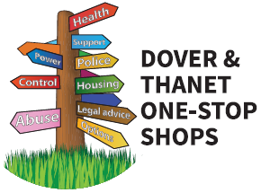

Anyone can access free and confidential specialist domestic abuse advise and information from a range of professionals

From the 6th of April 2021
- Monday – Thursday mornings between 10:00 and 12:00
- Call: 07856856278
- Email: EastKent1SS@gmail.com

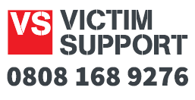
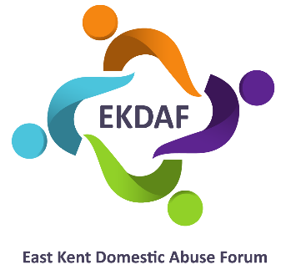

An administrator will take your call or email and arrange for an appropriate professional to get back to you by 12:00 that day

