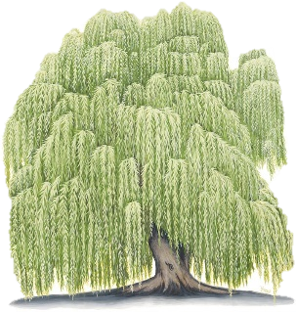

Termly Learning Bulletin



Willow Class – Term 2

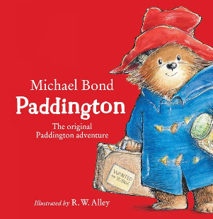

In English we will be:

* 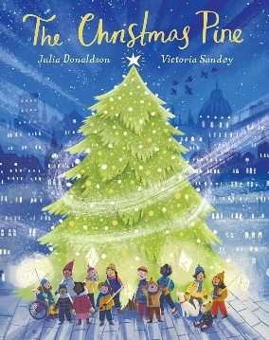Reading ‘Paddington’ by Michael Bond   
  and ‘The Christmas Pine’ by Julia Donaldson.
* Writing formal invitations and stories from  
  another culture.

In Maths we will be learning to:

* Addition and subtraction within 10 (Year 1)
* Addition and subtraction within 100 (Year 2)
* Geometry - shapes (Year 1)
* Geometry - shapes (Year 2)

We will also be learning about:

* Human and Physical features in Geography
* Food and nutrition in DT and Painting in Art
* ‘Celebrating Difference’ in PSHE
* Animals including humans in Science, including food chains
* Programing and video creation in Computing

Reminders!

P.E kit to be worn to school on Mondays and Thursdays

Reading books should be brought in **daily**.

Reading at home **daily**.