**Parents’ Guide to using Purple Mash**

Finding and completing activities set for your child:

1. To login to Purple Mash, you will need to make sure that you are accessing the specific ‘River Primary School’ Purple Mash.

<https://www.purplemash.com/sch/river>

The page to input your child’s username and password will look like this:

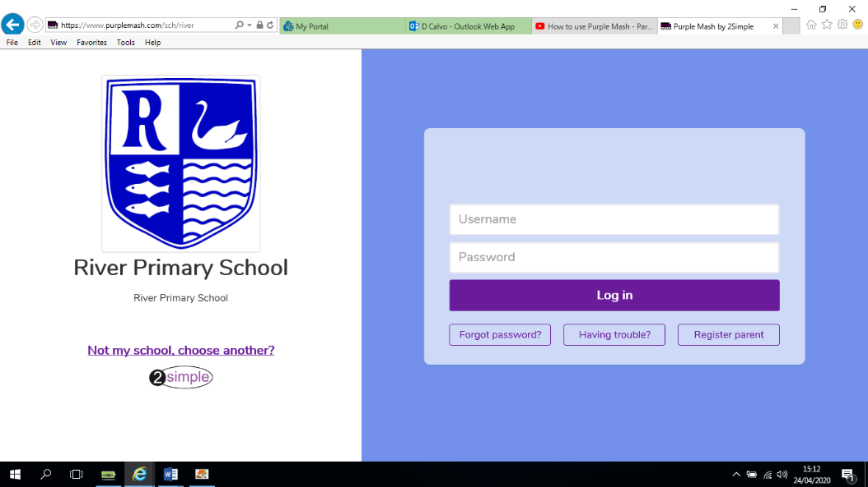

1. Once you have put in your child’s username and password you will see this screen:

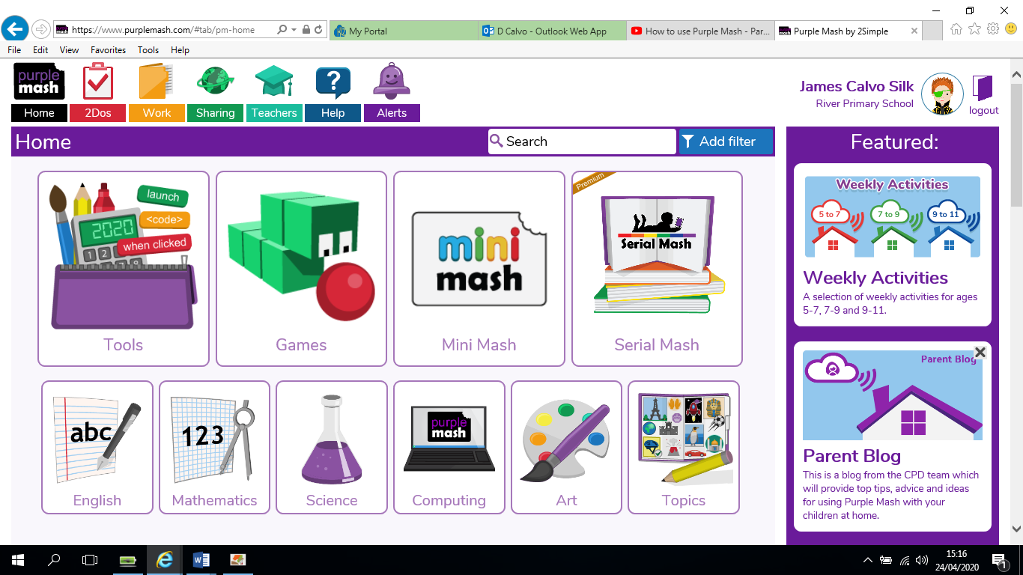

1. To access any work that your child’s teacher has set, click on **‘2Dos’** in the upper left hand corner.Any new activities set, will appear as an alert.

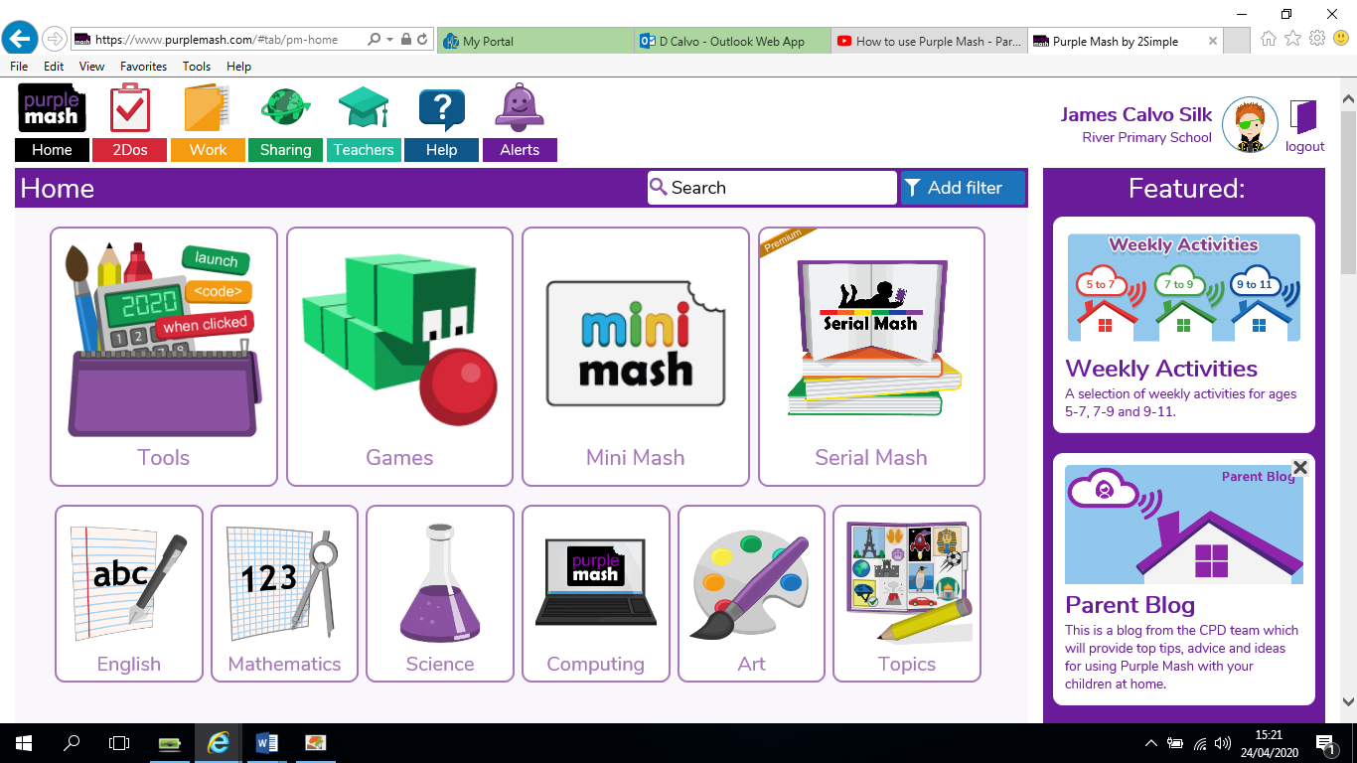

1. 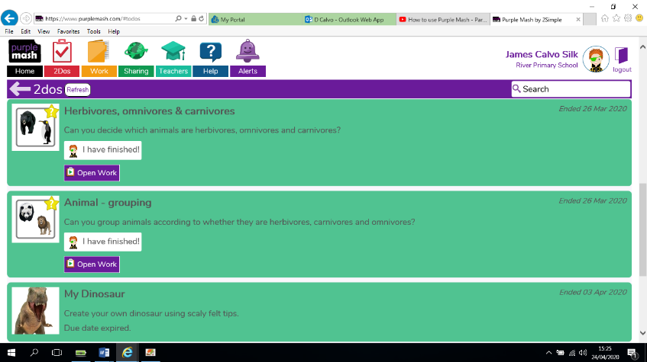Any work that has been set will be coloured in blue; any work that has been completed will be coloured in green. Like this:

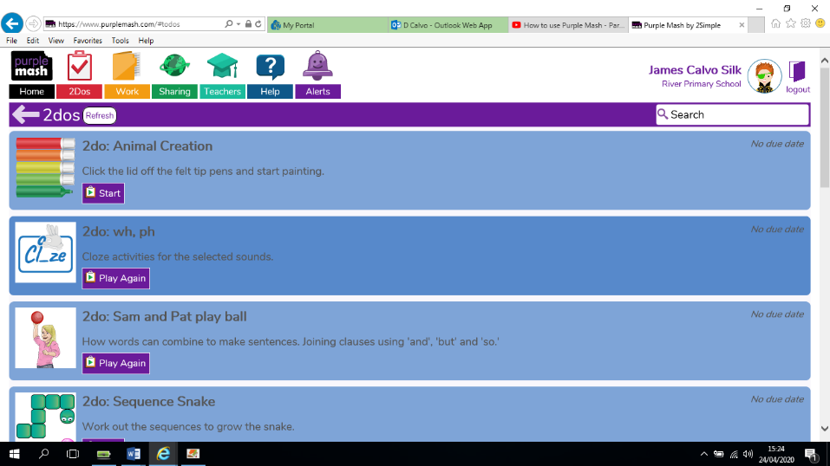

It will also tell you how long the work has been set for and how long your child has to complete the work.

1. Simply click the start button and your child can complete the activity.

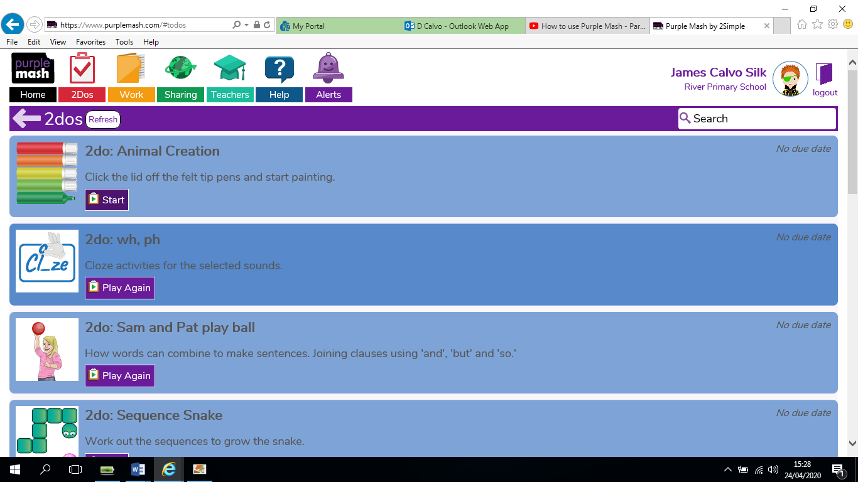

Finding Activities for your child

1. To find activities for your child that haven’t been set by the class teacher, you can search by using the search bar.

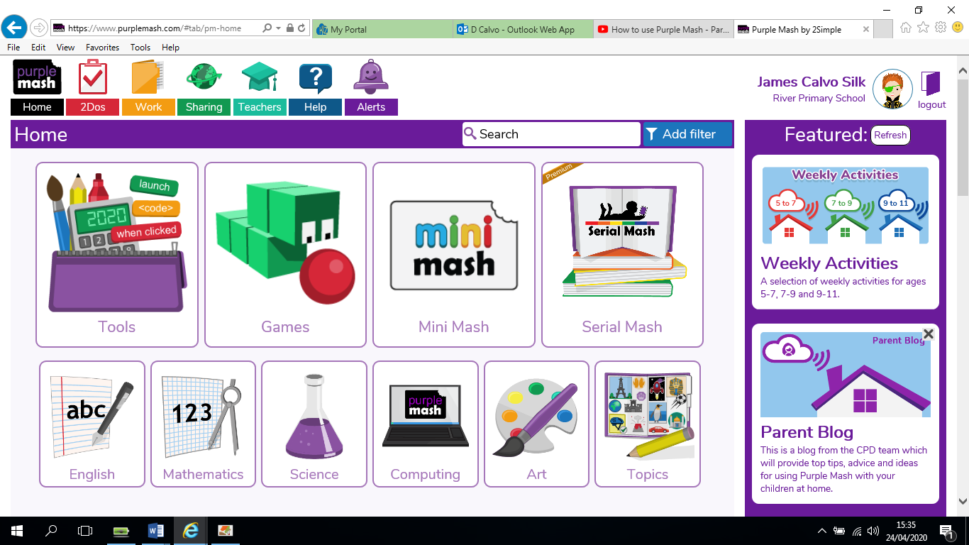

1. For example, if your child needs to practise number bonds, you can search ‘Number bonds’ in the search bar and you will be directed to these activities:

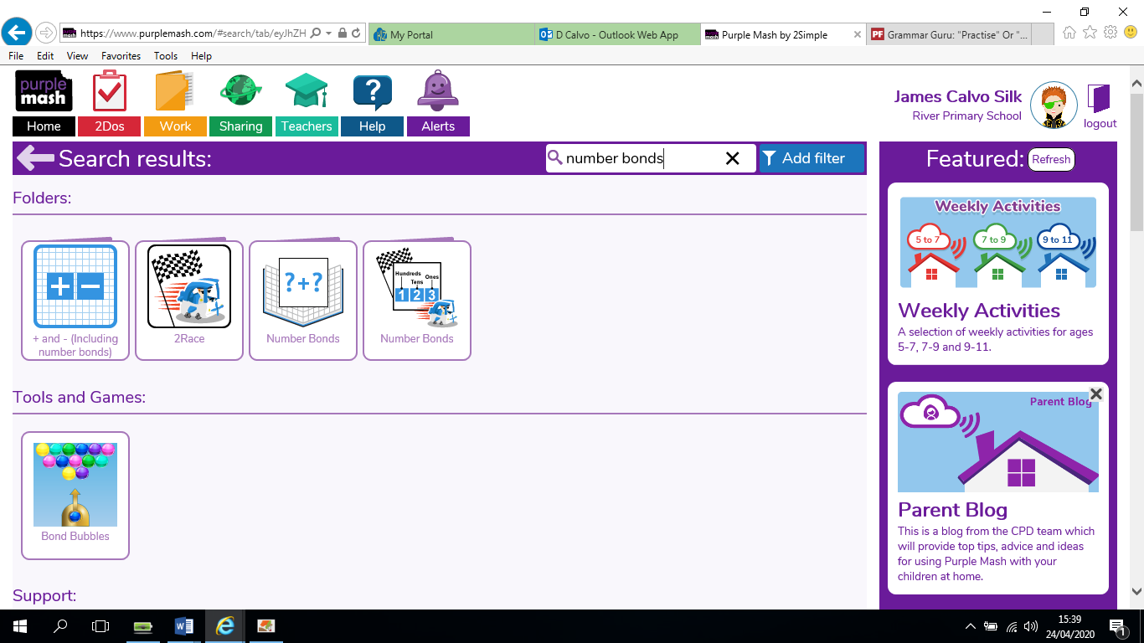

Tools and games are activities that they can complete themselves that will allow them to practise each skill.

Support gives different activities that you can use to support your child’s learning.

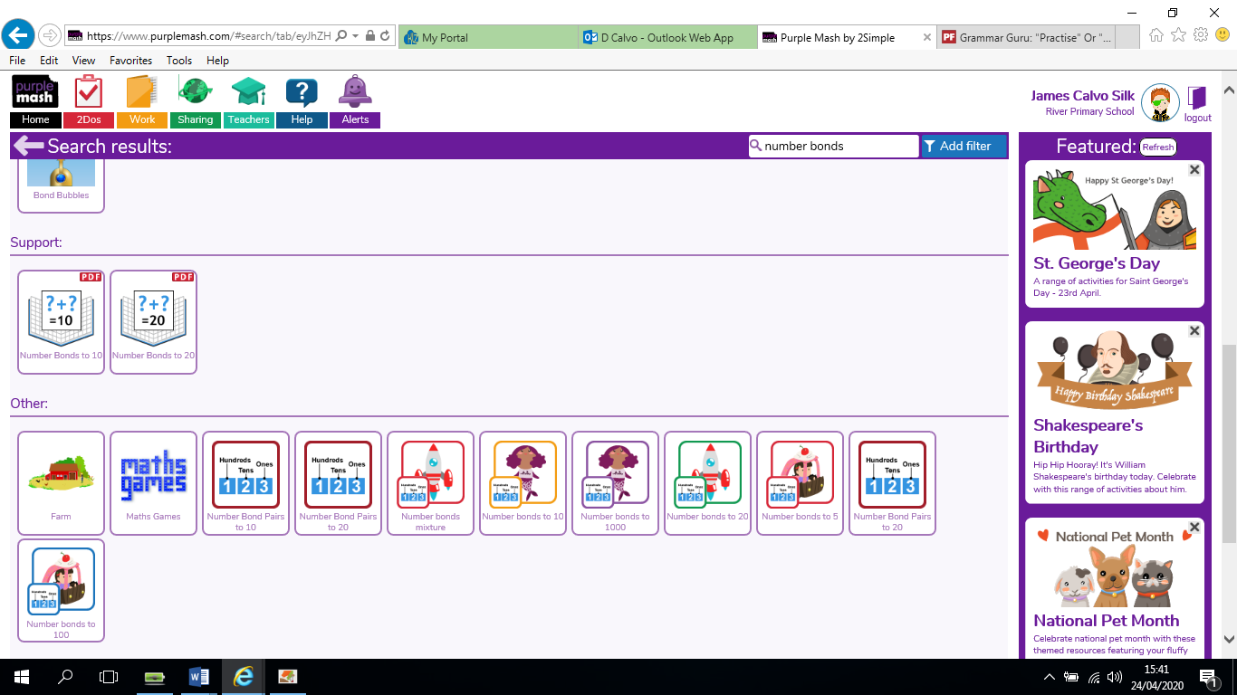

Other gives different activities that are similar or use similar skills to support your child’s learning.

**Additional Ideas**

If you are unsure which activities would be best to support your child, within each area of learning there are different learning activities for each year group. For example:

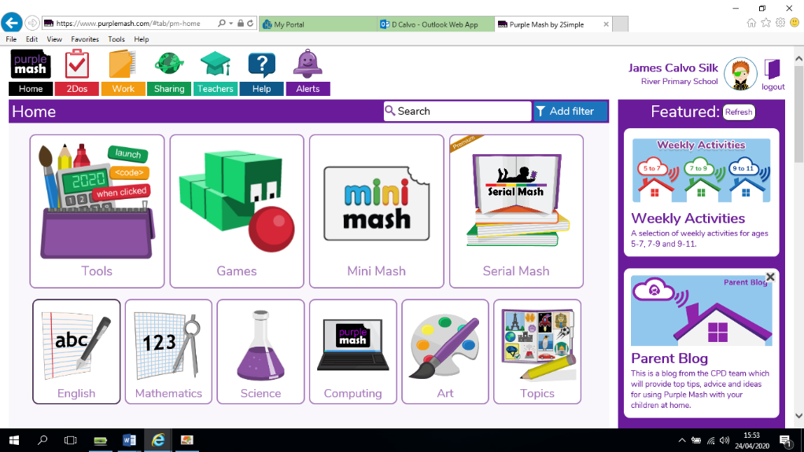

From the homepage, click on an area of learning. For this example, I have chosen ‘English.’

You then have options within each subject. So within English, I could choose:

* Spelling
* Grammar
* Phonics
* Writing frames

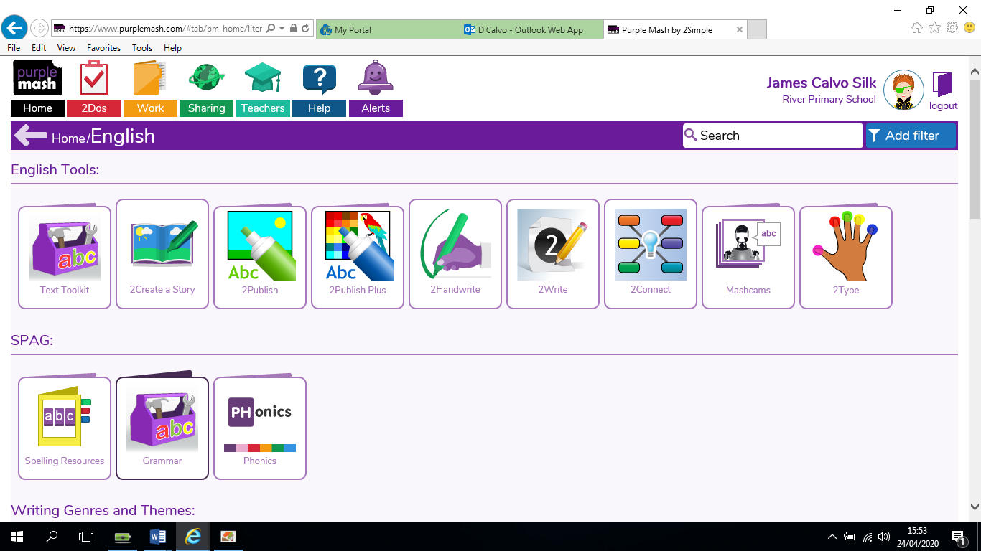

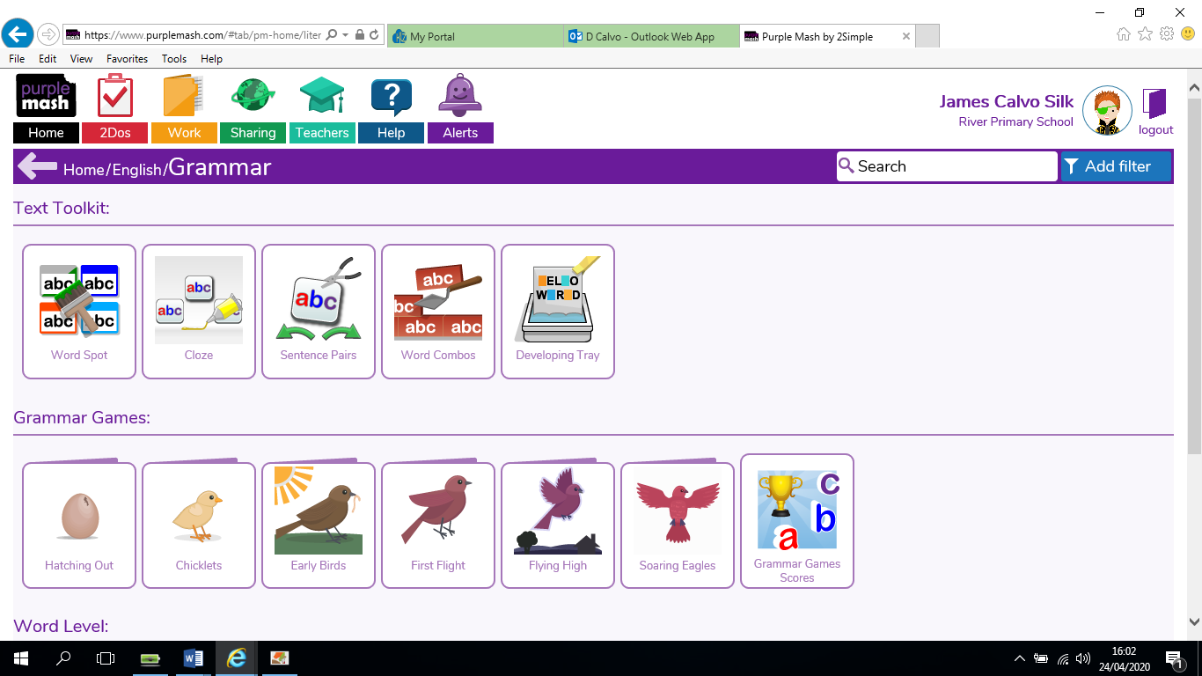

You then have options within each subject. I have chosen Grammar. For each year group:

* Year 1 – Hatching Out
* Year 2 – Chicklets
* Year 3 – Early Birds
* Year 4 – First Flight
* Year 5 – Flying high
* Year 6 - Soaring Eagles

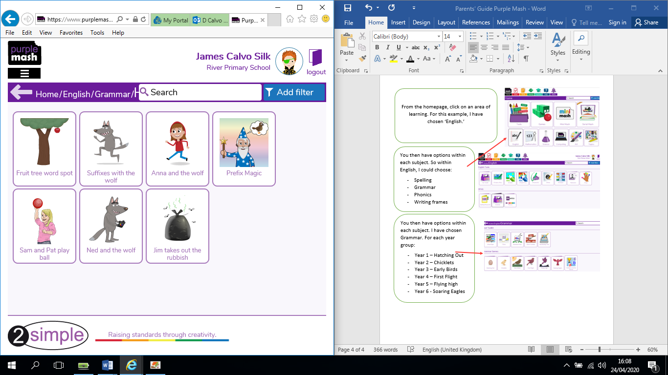

You will then have a range of activities that are suitable for children in your child’s Year group.

**Mini Mash - Reception**

For younger children, Mini Mash has lots of activities which may support their learning. First click on Mini Mash and then ‘Enter Mini Mash’.

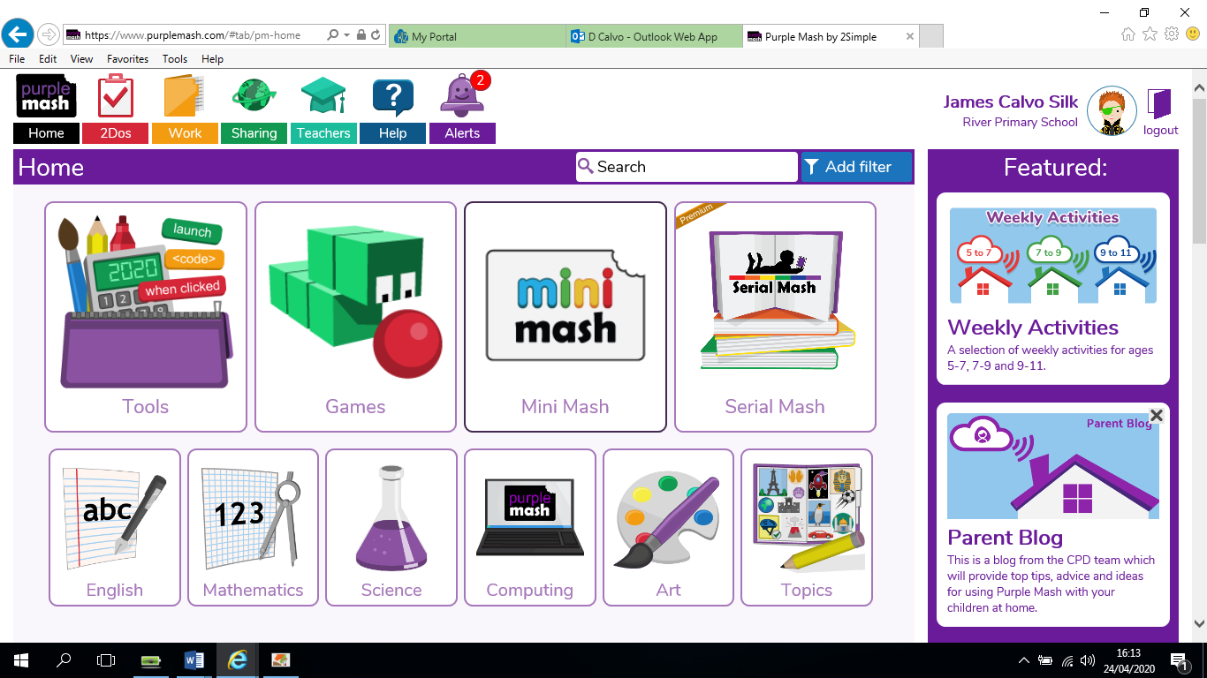

You will see this screen. When you click on a different section, you will be able to access activities for the following:

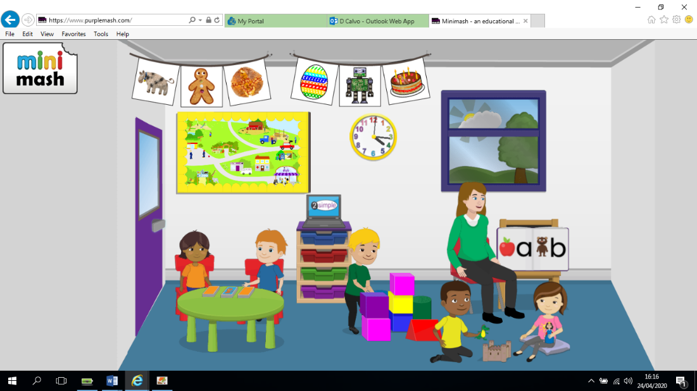

**Reading and writing –** alphabet games, phonics games.

**Art** – Complete different pictures using ICT skills

**Simple City** – videos and games about the world around us

**Games** –

jigsaws and pairs.

**Numbers and counting –** numbers, counting games, measuring