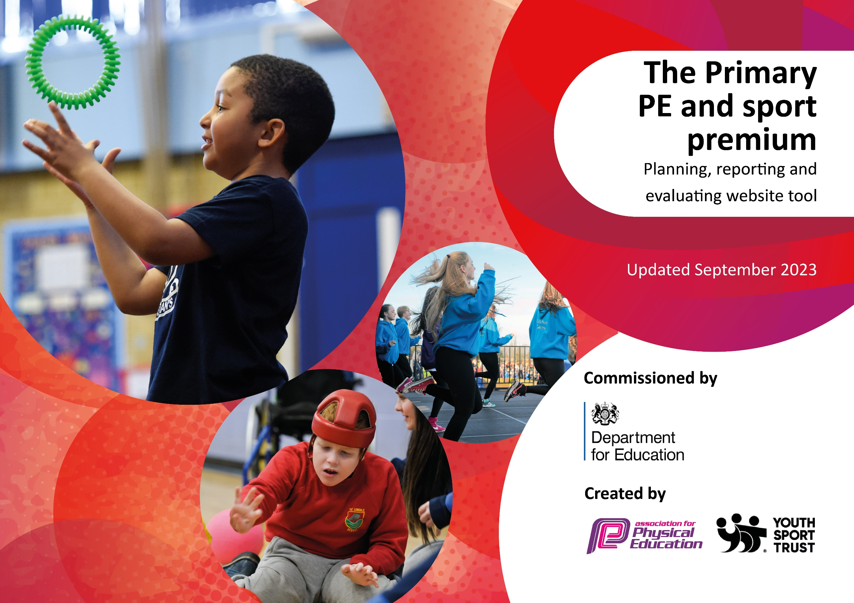

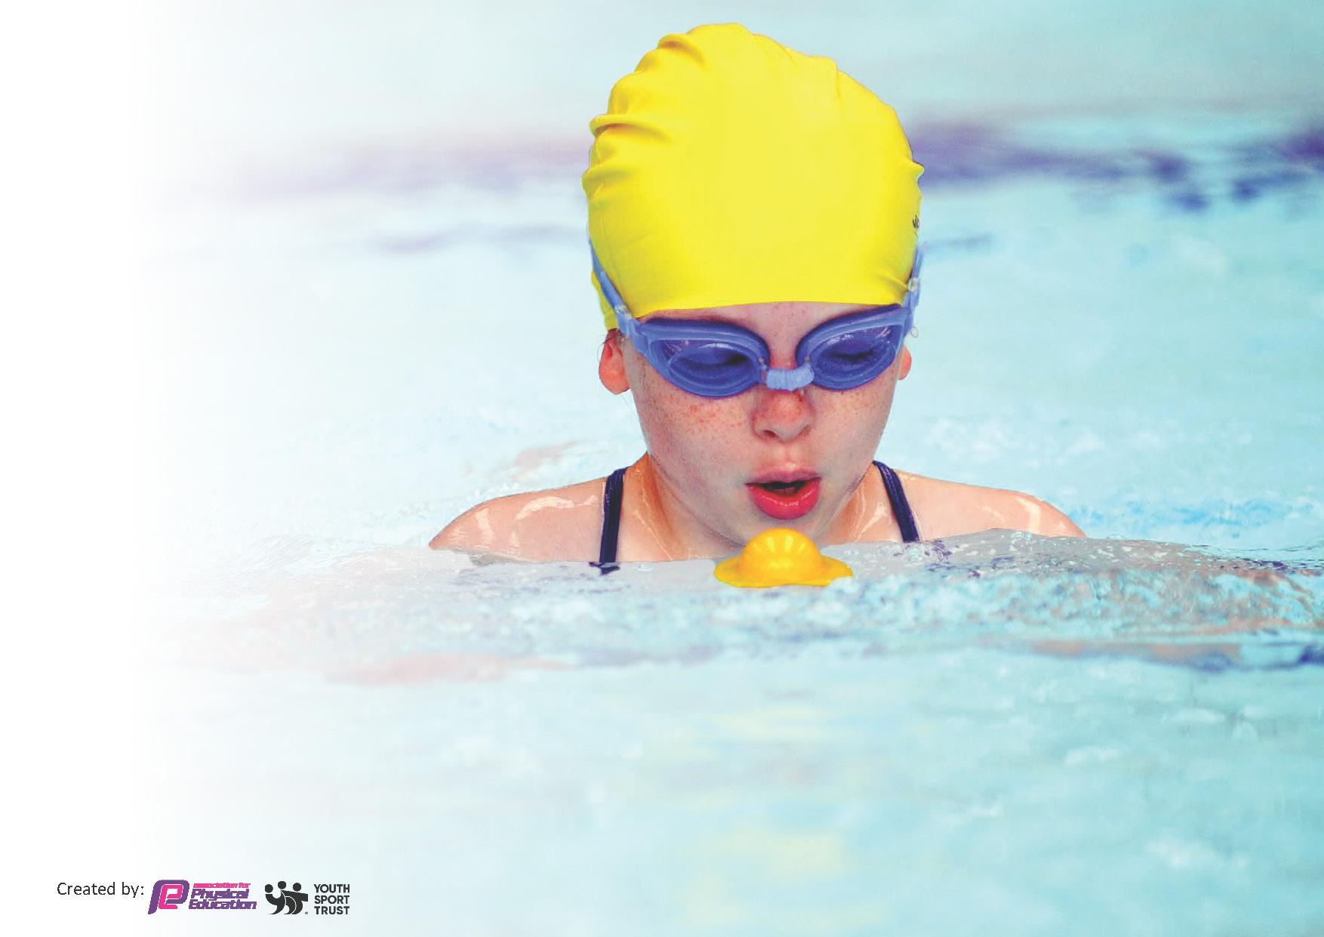
This template can be used for multiple purposes:
by:
- It enables schools to effectively plan their use of the Primary PE and sport premium
- It helps schools to meet the requirements (as set out in guidance) to publish information on their Primary PE and sport premium
- It will be an effective document to support Ofsted inspections enabling schools to evidence progress in Physical Education (PE) and evidence swimming attainment, which forms part of the PE National Curriculum. We would recommend schools consider
the Intent, Implementation and Impact of any spend, as examined within the Education Inspection Framework.

It is important that your grant is used effectively and based on school need.

Schools must use the funding to make additional and sustainable
improvements to the quality of the PE, School Sport and Physical Activity (PESSPA)
they offer. This means that you should use the Primary PE and sport premium to:

- Build capacity and capability within the school to ensure that improvements made now will benefit pupils joining the school in future years
- Develop or add to the PESSPA activities that your school already offers.

The Primary PE and sport premium should not be used to fund capital spend projects; the school’s core budget should fund these. Further detail on capital expenditure can be found in the updated Primary PE and sport premium guidance.

The Primary PE and sport premium guidance, outlines 5 key priorities that funding should be used towards. It is not

necessary that spending has to meet all the key priorities, you should select the priorities that you aim to use any funding towards.

Although completing this template is not a requirement for schools, schools are required to publish details of how they spend this funding. Schools must also outline what the impact this funding has had on pupils’ PE and sport participation and attainment and how any spending will be sustainable in the future. All funding must be spent by 31st July 2024.

The Department for Education has worked closely with the Association for Physical Education (afPE) and the Youth Sport Trust (YST) to develop this template and encourages schools to use it. This template is an effective way of meeting the reporting requirements of the Primary PE and sport premium.

Total amount allocated for 2023/24 | £16,675
Total amount to be spent 2023/24 | £16,675

Review of last year’s spend and key achievements (2022/2023)

We recommend you start by reflecting on the impact of current provision and reviewing your previous spend.

Activity/Action | Impact | Comments
Main achievements  Introduction of yoga to the curriculum delivered by outside provider.  Enhancing gymnastics equipment.  Provide all pupils with a positive, high-quality  experience and PE and Sport within school. | Every child is accessing two sessions a term learning calming techniques to support, when required and provide CPD for teaching staff.  Provides opportunities for use of wall apparatus, traversing wall and additional mats which were otherwise inaccessible.  All children received high quality PE provision, staff received CPD and subject lead developed. | Continuous programme of yoga sessions to be booked for 2023/24.  Children continuing to benefit from enhanced gymnastics learning.  To continue CPD with new PE lead and CPD training for staff.

Key priorities and Planning
This planning template will allow schools to accurately plan their spending.

Action – what are you planning to do | Who does this action impact? | Key indicator to meet | Impacts and how sustainability will be achieved? | Cost linked to the action  Allocated  Actual spend
To use current School Games  criteria to select pupils to  attend events  Dover School Games Buy in  competition package. To  offer pupils higher level of  competitive competition  To enter boys football league and cup competitions  All pupils to participate in  termly Intra-sport competitive  competitions  All pupils across the whole school to participate in  competitive sports day  Transport when required to be  booked to enable pupils to  attend competitive  competitions  All pupils from EYFS to year 6 to participate in 2 sessions of yoga across each term.  Provide Active Play opportunities for all pupils to access regular daily physical activity contributing towards 60mins of daily physical activity.  All equipment required to deliver PE and Games within the curriculum. Ensure continued level of engagement of all pupils.  To purchase AFPE membership to allow up to date information for all aspects within PESSPA. SL to access current up to date information SL to attend webinars to develop own CPD.  To continue to support and upskill both teaching and support staff across the whole school within PE and Games To support confidence and subject knowledge for all teaching and support staff. To supporting teaching staff to structure and deliver high quality teaching and learning for all pupils across dance and gym.  To provide outdoor physical experiences linked to year group learning to enhance skills and participation in groups.  Purchase Safe Practice book rom AFPE website to ensure all current health and safety requirements in PESSPA are adhered  to. | PE SL Pupils Support staff  PE SL  All teaching staff  Pupils  PE SL  All support staff  Pupils  PE SL  Business manager  Pupils  PE SL  HoS  Business manger  PE SL  Business manager  All teaching staff  Pupils  Pupils  Tas  Teachers  Business manager to purchase book SL to share with all members of staff | KI5. Increased participation in competitive sport  KI2: Engagement of all pupils in regular physical activity & KI5: Increased participation in competitive sport  KI5: Increased participation in competitive sport  KI3: The profile of PE and sport is raised across the school as a tool for whole school improvement  KI2: Engagement of all pupils in regular physical activity & KI5: Increased participation in competitive sport  KI4: Broader experience of a range of sports and activities offered to all pupils  KI 4 Broader experience of a range of sports and activities offered to all pupils.  KI2 Engagement of all pupils in regular physical activity & KI3: The profile of PE and sport is raised across the school as a tool for whole school improvement  KI2 Engagement of all pupils in regular physical activity & KI1 Increased confidence, knowledge and skills of all staff in teaching PE and sport  KI1 Increased confidence, knowledge and skills of all staff in teaching PE and sport  KI1 Increased confidence, knowledge and skills of all staff in teaching PE and sport  KI 4 Broader experience of a range of sports and activities offered to all pupils.  KI1 Increased confidence, knowledge and skills of all staff in teaching PE and sport | All pupils will experience competitive sport on a termly basis through participating in year group intra-sport competitions. A high number of pupils from KS2 will participate in competitive competitions at a level linked to their confidence and sporting ability. A high number of pupils will compete in a variety of different sporting events including inclusive, intra, inter and county level competitions.  All pupils from EYFS to year 6 will participate in yoga exercises. Developing calming and relaxation techniques to support mental health and well-being.  All pupils from EYFS to Year 6 to attend forest school sessions once a term by trained professional to improve skills, awareness of outside activity and teamwork. All pupils to receive cross curricular learning outside of the classroom using maps and linking knowledge. | Dover School Games: £325  Lydden Tshirt Print: £140  Football League: £50  Restock Kit: £47.12  Football Goals: £487.18  Sports medals £114  Award stickers £23.26  Hula Hoops £41.99  Clipboards £23.98  ‘LYDDEN’ tshirts £140  Britannia £190 to athletics for two classes  Once upon the Mat £1440  KS1 Tennis Net £48  £709.80 spent using Sports for Schools voucher earnt from Sponsored Fitness circuit *not from budget  Sports Ambassador bibs and badges £30.80  ActivAll Portable Board £5095  Sports Equipment:  Ruby balls/tags  10 x hockey sticks  Badminton rackets, shuttlecocks, springboard and dodgeballs  Folding foam wedge  LTA voucher overspend £0.49  Basketball backboards  Total: £2,171.92  year membership: £128  AS CPD to teachers/Tas  £947.84 per visit  (3 x days a term)  Total: £2,843.52  Every term with total cost £2,535.23 over year  Cross Curricular Subscription £600  Skate School Experience Morning £200

Key achievements 2023-2024
This template will be completed at the end of the academic year and will showcase the key achievements schools have made with their Primary PE and sport premium spending.

Activity/Action | Impact | Comments
CPD dance and gym all teachers/support staff  Equipment  Forest school  Active Play | Teachers now feel confident to plan, teach, assess and next steps  Higher quality teaching and learning  More diverse physical opportunities and CPD for staff  Children able to access more equipment regularly and staff more aware of activities that could be implemented. | Check ins with teacher 2024/2025 to be observed in dance and gym to ensure developed confidence, actioning CPD. Use of roll mat implemented after training.  All pupils have increased skills, knowledge and vocabulary while having access to higher quality equipment as well as new apparatus.  Continued next year with longer sessions and CPD for staff.  Continue to develop variety of activities and frequency to keep children active.

Swimming Data
Meeting National Curriculum requirements for swimming and water safety.
Priority should always be given to ensuring that pupils can perform safe self-rescue even if they do not fully meet the first two requirements of the National Curriculum programme of study

Question | Stats: | Further context  Relative to local challenges
What percentage of your current Year 6 cohort can swim competently, confidently and proficiently over a distance of at least 25 metres? | 86% | Child was not able to confidently complete 25 metres.
What percentage of your current Year 6 cohort can use a range of strokes effectively [for example, front crawl, backstroke, and breaststroke]? | 100% | All able to swim effectively each stroke.

What percentage of your current Year 6 cohort are able to perform safe self-rescue in different water-based situations? | 100% | All able to get in and out safely etc.
If your schools swimming data is below national expectation, you can choose to use the Primary PE and sport premium to provide additional top-up sessions for those pupils that did not meet National Curriculum  requirements after the completion of core lessons. Have you done this? | No
Have you provided CPD to improve the knowledge and confidence of staff to be able to teach swimming and water safety? | No | Trained swim instructors used to carry out lessons.

Signed off by:

Head Teacher: | (Name)
Subject Leader or the individual responsible for the Primary PE and sport premium: | (Name and Job Title)
Governor: | (Name and Role)
Date:

