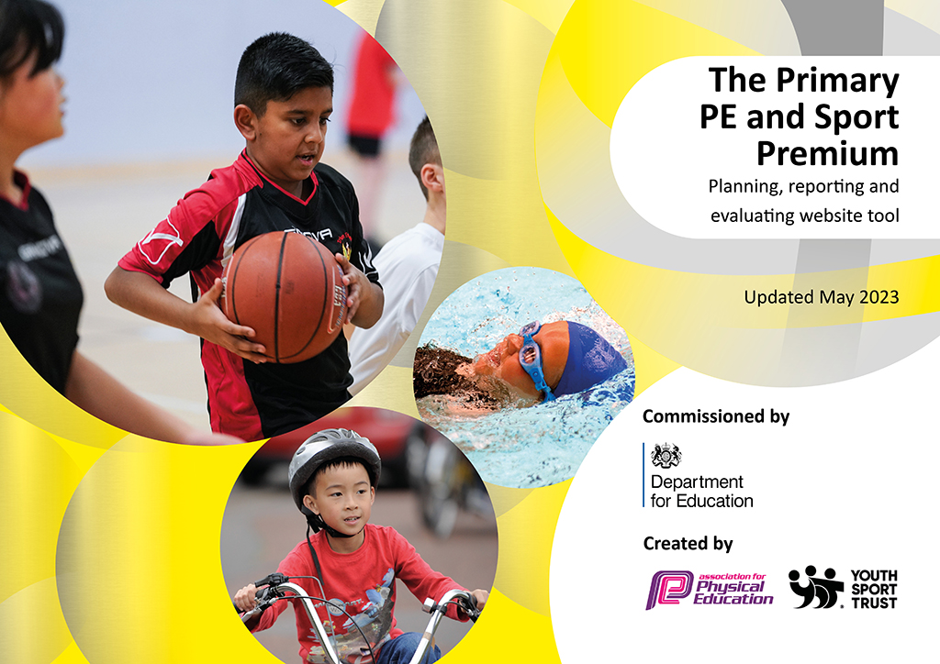
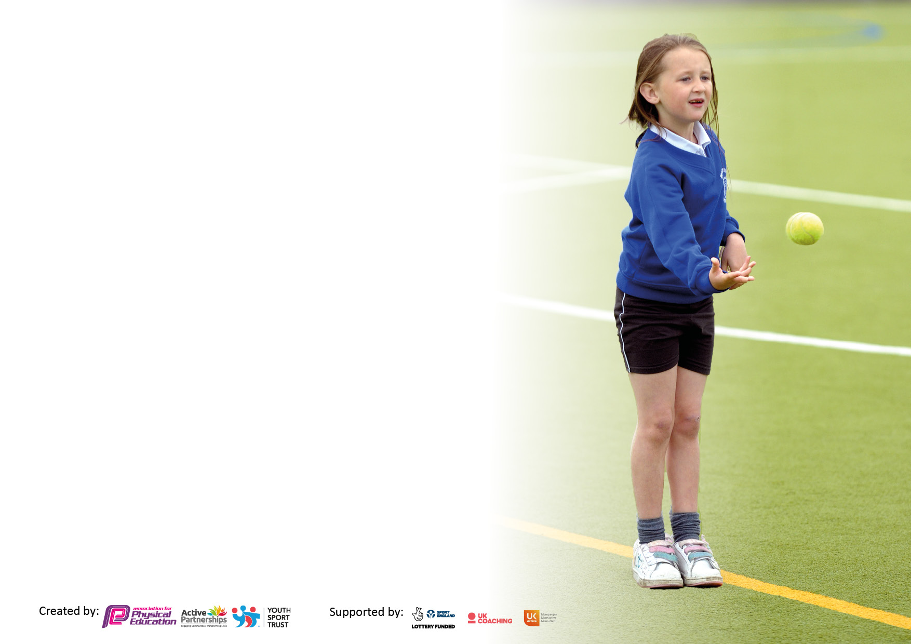

It is important that your grant is used effectively and based on school need. The Education Inspection Framework makes clear there will be a focus on ‘whether leaders and those responsible for governors all understand their respective roles and perform these in a way that enhances the effectiveness of the school’.

Under the Quality of Education judgement, Ofsted inspectors consider:
Intent - Curriculum design, coverage and appropriateness
Implementation - Curriculum delivery, teaching (pedagogy) and assessment
Impact - Attainment and progress

To assist schools with common transferable language, this template has been developed to utilise the same three headings which should make your plans easily transferable between working documents.

Schools must use the funding to make additional and sustainable improvements to the quality of Physical Education, School Sport and Physical Activity (PESSPA) they offer. This means that you should use the Primary PE and sport premium to:

- Develop or add to the PESSPA activities that your school already offers
- Build capacity and capability within the school to ensure that improvements made now will benefit pupils joining the school in future years
- The Primary PE and sport premium should not be used to fund capital spend projects; the school’s budget should fund these.

Please visit https://www.gov.uk/guidance/pe-and-sport-premium-for-primary-schools for the revised DfE guidance, including the 5 key indicators across which schools should demonstrate an improvement. This document will help you to review your provision and to report your spend. DfE encourages schools to use this template as an effective way of meeting the reporting requirements of the Primary PE and Sport Premium.

We recommend you start by reflecting on the impact of current provision and reviewing the previous spend.

Schools are required to publish details of how they spend this funding, including any underspend from 2021/2022, as well as on the impact it has on pupils’ PE and sport participation and attainment.

We recommend regularly updating the table and publishing it on your website throughout the year. This evidences your ongoing self-evaluation of how you are using the funding to secure maximum, sustainable impact. Final copy must be posted on your website by the end of the academic year and no later than the 31 July 2023.

Details with regard to funding
Please complete the table below.

Total amount carried over from 2021/22 | £00000
Total amount allocated for 2022/23 | £16675
How much (if any) do you intend to carry over from this total fund into 2023/24? | £00000
Total amount of funding for 2022/23 to be reported on by 31st July 2023 | £ 16675
Swimming Data
Please report on your Swimming Data below.

Meeting national curriculum requirements for swimming and water safety.

N.B. Complete this section as best you can. For example, you might have practised safe self-rescue techniques on dry land which you can then transfer to the pool when school swimming restarts.
Due to exceptional circumstances priority should be given to ensuring that pupils can perform safe self-rescue even if they do not fully meet the first two requirements of the NC programme of study
What percentage of your current Year 6 cohort swim competently, confidently and proficiently over a distance of at least 25 metres?  N.B. Even though your pupils may swim in another year, please report on their attainment on leaving primary school at the end of the summer term 2023.  Please see note above | 91%
What percentage of your current Year 6 cohort use a range of strokes effectively [for example, front crawl, backstroke and breaststroke]?  Please see note above | 91%
What percentage of your current Year 6 cohort perform safe self-rescue in different water-based situations? | 91%
Schools can choose to use the Primary PE and sport premium to provide additional provision for swimming, but this must be for activity over and above the national curriculum requirements. Have you used it in this way? | No

Action Plan and Budget Tracking
Capture your intended annual spend against the 5 key indicators. Clarify the success criteria and evidence of impact that you intend to measure to evaluate for pupils today and for the future.

Academic Year: 2022/23 Lydden Primary | Total fund allocated: £16675 | Date Updated: September 22, February 23 July 23
Key indicator 1: Increase confidence, knowledge and skills of all staff in teaching PE and sport |  |  |  | Percentage of total allocation:
 |  |  |  | %
Intent | Implementation |  | Impact
Your school focus should be clear on what you want the pupils to know and be able to do. What do they need to learn and to consolidate through practice: | Make sure your actions to achieve are linked to your intentions: | Funding allocated:  £590  Actual spend £590 | Evidence of impact:  What do pupils now know and what can they now do? What has changed? | Sustainability and suggested next steps:
All teaching and support staff to attend Yoga sessions delivered by outside provider  All staff to use CPD opportunity from these sessions  All staff to use calming techniques taken from sessions when required by pupils | SL to research and book outside provider within Yoga  SL to complete timetable for whole school to access sessions throughout academic year | £ Please see KI 4 | 4 CT and 7 TA’s have attended Yoga sessions provider by qualified Yoga outside provider.  All staff more confident to use calming techniques when required by pupils. | Yoga sessions booked for academic year 2023/24.
To purchase AFPE membership to allow up to date information for all aspects within PESSPA.  SL to access current up to date information  SL to attend webinars to develop own CPD | Business manager and SL to sign up to AFPE  SL to use AFPE website on regular basis | £128 | SL kept up to date with latest initiatives to ensure all pupils are being as physically active within the latest government guidelines.  SL to complete webinars to ensure school is working in line with latest evidence and guidance, | Renew membership for academic year 2023/24.
Purchase Safe Practice book rom AFPE website to ensure all current health and safety requirements in PESSPA are adhered to. | Business manager to purchase book  SL to share with all members of staff  SL release time  New SL expenses | £45  £416.98 | SL and SLT aware of guidelines and up to date safe practice within all areas of PE and School Sport.  New SL to fill confident within new role.  Transition will allow for SL to deepen teaching and learning within PE and School Sport in readiness for academic year 2023/24. | Replace with next edition when required.  SL will continue to support transition for academic year 2023/24.
SL to meet with new SL for transition of information and resources
SL to support new SL in implementing curriculum, updating website, writing intend and implication statements.

Key indicator 2: The engagement of all pupils in regular physical activity – Chief Medical Officers’ guidelines recommend that  primary school pupils undertake at least 30 minutes of physical activity a day in school |  |  |  | Percentage of total allocation:
 |  |  |  | %
Intent | Implementation |  | Impact
Your school focus should be clear on what you want the pupils to know and be able to do. What do they need to learn and to consolidate through practice: | Make sure your actions to achieve are linked to your intentions: | Funding allocated:  £7710  Actual spend £7710 | Evidence of impact:  What do pupils now know and what can they now do? What has changed? | Sustainability and suggested next steps:
Provide all pupils with a positive, high-quality experience and PE and Sport within school. | SL to Lead subject forward to monitor progression and attainment of all pupils.  Track and engage less active pupils, vulnerable groups of pupils, such as PP children, disadvantaged pupils.  Use School Games Website to complete the 2022-23 Inclusive Health Check,  Complete the School Games Mark application and complete self-review tool School Games Mark Framework  Access competitive sport for a high percentage of pupils across the school at levels 1,2 and 3.  Oversee all extra-curricular clubs for all pupils.  Complete and deliver sports premium funding plan. Ensuring that all pupils learning and physical experience is enhanced through effective planning and delivery. | £7463 | All pupils have access to 2 hours high quality PE and Games teaching and learning weekly. Pupils now know new skills and knowledge surrounding being active, engaging in a range of sports and ways to lead an active healthy lifestyle.  All pupils assessed on target Tracker by class teacher with discussion from SL.  SL completed Heat Map and plan to be implemented for impact on all pupils for academic year 2022-23.  School games mark completed – Gold level achieved.  95% of KS2 pupils have accessed level 2 participation/competitive competition experience. Developing teamwork/sportsmanship and that sport is fun.  Pupils have accessed 3 after school clubs on a weekly basis across the whole academic year.  Plan updated and reported to governors 3 times per academic year. Ensure that all pupils have a broader and deeper sporting opportunity. All pupils have the same experience within PE and Games. | SL to work with new SL to allow for smooth transition of knowledge and skills to lead PE and School Sport.  SL to facilitate CPD for new SL and all teaching staff in academic year 2023/24.
Provide Active Play opportunities for all pupils to access regular daily physical activity | Active Play equipment to enhance provision provided.  Active Play to have zoned areas for participation in different activities  Pupil voice used to structure the games offered  Support staff to lead and engage with all pupils  SL and SLT to oversee provision is offered daily | Estimated £500  £147.62 | All pupils are physical active for 45mins daily through structured adult led games activities. | SL to continue to provide timetables for staff and timetables of activities available for pupils for academic year 2023/4. This will be done through the use of pupil voice.
All equipment required to deliver PE and  Games within the curriculum.  Ensure continued level of engagement of all pupils | SL to purchase new equipment, to enhance the range of sports on offer to all pupils. | Estimated £500  £100 | All pupils have access to a broad curriculum within Games. All pupils deepen their knowledge and understanding of being physically active and what a healthy active lifestyle is. | SL to continue to research new and exciting opportunities for all pupils to encourage a love of sport and the benefits of a physical active lifestyle.  New hall built completed July 2023.  All pupils will access a broad curriculum within Gym, Dance and Games for academic year 2023/24.

Key indicator 3: The profile of PE and sport is raised across the school as a tool for whole school improvement |  |  |  | Percentage of total allocation:
 |  |  |  | %
Intent | Implementation |  | Impact
Your school focus should be clear on what you want the pupils to know and be able to do. What do they need to learn and to consolidate through practice: | Make sure your actions to achieve are linked to your intentions: | Funding allocated:  £985  Actual spend £984 | Evidence of impact:  What do pupils now know and what can they now do? What has  changed? | Sustainability and suggested next steps:
Supplies for forest school activities to enhance learning for all pupils | Forest school provider to supply additional resources  Sl to sign off agreed amount | £63.17 | All pupils have deepened their understanding of the outdoor environment. Have achieved a termly outcome linked to their topic. | Forest school booked for all pupils term 1 and 2.
All pupils to access active learning through Cross Curricular Orienteering x3 15mins weekly sessions  Pay annual Cross Curricular Orienteering subscription fee for new and additional resources for all pupils within school  Increase cross-curricular links with PE  To provide all KS2 pupils with Orienteering competition with live leader board updates to promote competition using school values | Access school portal for support and learning resources  Year 1/2 and KS2 teachers to share maps and learning resources created on a weekly basis  Business manager to pay annual subscription fee  SL to research and book opportunity for all KS2 pupils  SL to produce timetable for day  Whole day provided by outside providers | £480  £440.75 | All pupils from year 1-6 have completed learning within games and ready to access cross-curricular orienteering. Pupils able to use map reading skills to be able to complete learning in a more active way.  All pupils took part in day, using their own level of personal challenge and fitness to complete the challenge. | All CT’s to offer active learning at least 3 times a week within cross-curricular learning.  SL to lead CPD session in T1.  SL to continue to monitor new and exciting challenges to encourage a love of being physically active.
Key indicator 4: Broader experience of a range of sports and physical activities offered to all pupils |  |  |  | Percentage of total allocation:
Intent | Implementation |  | Impact
Your school focus should be clear on what you want the pupils to know and be able to do. What do they need to learn and to consolidate through practice: | Make sure your actions to achieve are linked to your intentions: | Funding allocated:  £6810  Actual spend  £6805 | Evidence of impact:  What do pupils now know and what can they now do? What has  changed? | Sustainability and suggested next steps:
All pupils to attend Yoga sessions throughout academic year from an outside provider.  Pupils will learn and consolidate how Yoga can support mental health and well being | SL to research and book outside provider within Yoga  SL to complete timetable for whole school to access sessions throughout academic year | £1280 | All pupils have experience Yoga as a way to be active, a way to relax and improve mental health and well-being. To improve body strength, balance and flexibility. | Yoga sessions booked for academic year 2023/24.
Subscribe to sports magazines to engage reluctant readers to read for pleasure. | SL and ESL to reflect on impact of pupils engagement  Research magazines to reflect pupils interests | Estimated  £139 | All pupils sharing newspapers and reading for enjoyment. | SL and ESL to reflect on impact of this throughout the academic year.
To research and purchase wall bars, traversing wall and low level Gymnastics equipment. All pupils will be able to develop climbing, core strength and flexibility through enhanced opportunities. | SL to research wall bars traversing wall and low level equipment  SL and HoS to agree on equipment to purchase  SL to order all equipment required  SL to offer CPD to all staff in respect of enhanced learning and safety | Estimated  Wall bars £4233  Traversing wall £650  Mats £428 | All pupils will receive enhanced teaching and learning within gymnastics. Pupils will develop strength and flexibility | SL to provide CPD for all staff in gymnastics in T2 academic year 2034/24
All gym equipment to be inspected at start of academic year | BM to arrange | £75 | All pupils able to access high quality teaching and learning using safe and appropriate equipment. | Equipment checks booked for academic year 2034/24

Key indicator 5: Increased participation in competitive sport |  |  |  | Percentage of total allocation:
 |  |  |  | %
Intent | Implementation |  | Impact
Your school focus should be clear on what you want the pupils to know and be able to do. What do they need to learn and to consolidate through practice: | Make sure your actions to achieve are linked to your intentions: | Funding allocated:  £590  Actual spend £586 | Evidence of impact:  What do pupils now know and what can they now do? What has  changed? | Sustainability and suggested next steps:
Offer level 2 competitions to a large percentage of pupils across whole school  To use current School Games criteria to select pupils to attend events | SL to attend DSG meeting  SL to track all children attending events  SL to follow School Games criteria to select appropriate children for events | N/A | Pupils confidence increased and experience of participating in competitive sport. | Pupils will be entered into all DSG competitions and additional opportunities when arising.
Dover School Games Buy in competition package. To offer pupils higher level of competitive competition | SL to attend DSG meeting  SL to follow School Games criteria to select appropriate children for events | £300 | Pupils participated in 4 out of 6 competitions. All competitors developed understanding of competitive sport. | SL to buy into competitive package for next academic year to ensure a higher level of competition for more abled pupils within sport.
All pupils to participate in termly Intra-sport competitive competitions | SL and pupils to plan termly intra-sport competitive competitions for all pupils  SL to work with year 5/6 pupils to officiate within a number of different fundamental events (KS1) and sports (KS2) | Estimated  £100 | All pupils have a better understanding of competitive sport. Year 5/6 pupils have experienced leadership and officiating roles within sport. | Fill programme of intra-sport opportunities will be completed across every term for all pupils.
All pupils across the whole school to participate in competitive sports day | SL to plan and deliver sports days for whole school | Estimated £150  £91.20 Medals | All pupils participated in competitive sport, developing and understanding of how to be a good sportsman | Sports day booked for next year.
Sports T-Shirts to wear to competitive events | SL to research T-Shirts and printing | Estimated  £200  T-shirts £95.91  Printing | Pupils able to feel part of a team and enjoy representing school at sporting events. | T-shirts available for all pupils for sports competitions academic year 2023/24
Transport when required to be booked to enable pupils to attend competitive competitions | SL and office staff to research and book all transport required | Estimated £400  £99 Sportshall Athletics | Pupils offered the opportunity to compete at level 2 events. Understanding the next level of competition, of working within a team and demonstrating sportsmanship and respect when representing the school. | Level 2 sports opportunities will continue to be offered to a high percentage of pupils across the school year.

Signed off by
Head Teacher:
Date:
Subject Leader:
Date:
Governor:
Date:

