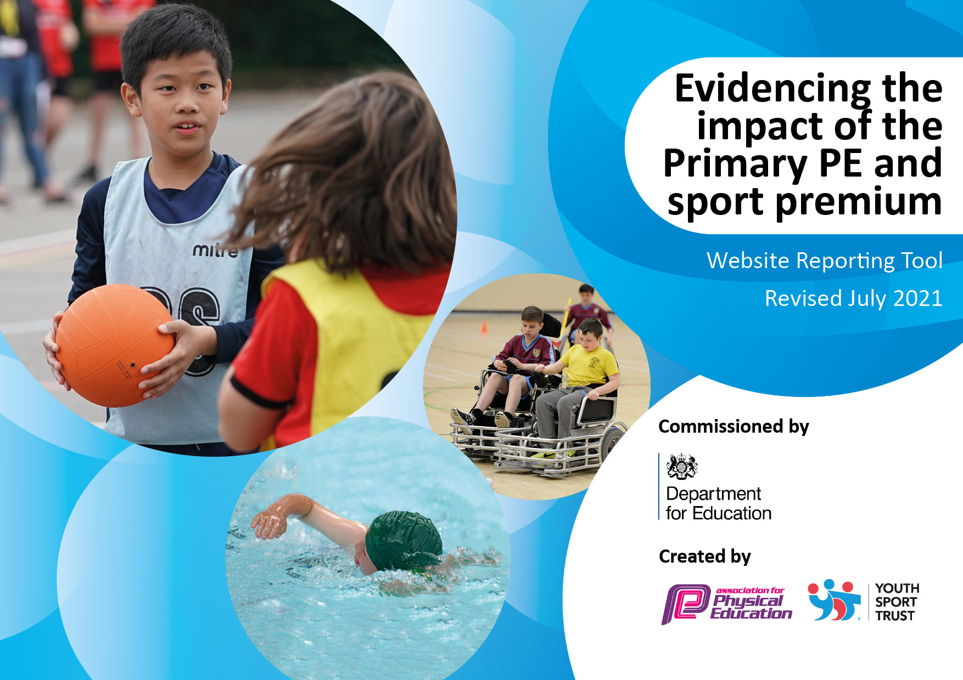
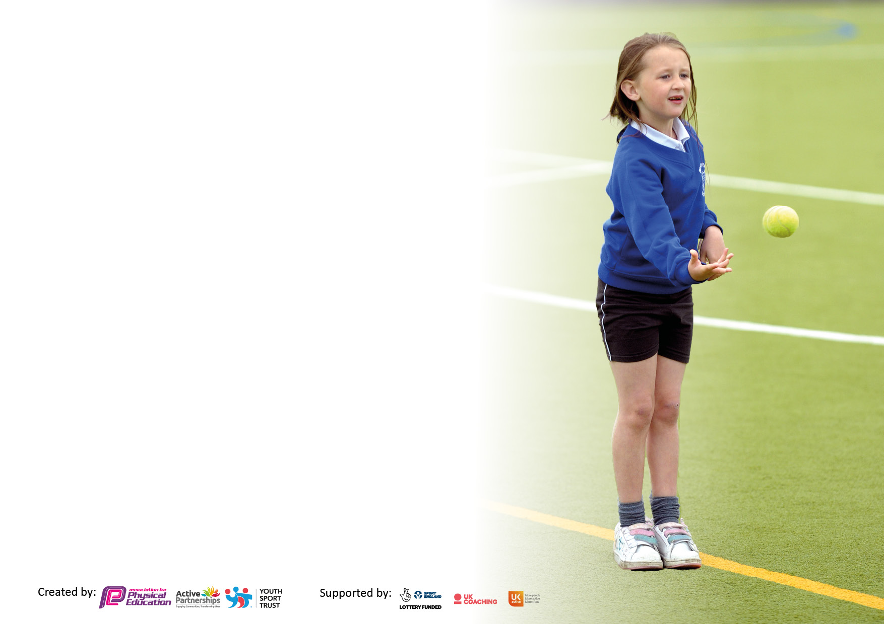

It is important that your grant is used effectively and based on school need. The Education Inspection Framework makes clear there will be a focus on ‘whether leaders and those responsible for governors all understand their respective roles and perform these in a way that enhances the effectiveness of the school’.

Under the Quality of Education Ofsted inspectors consider:
Intent - Curriculum design, coverage and appropriateness
Implementation - Curriculum delivery, Teaching (pedagogy) and Assessment
Impact - Attainment and progress

To assist schools with common transferable language this template has been developed to utilise the same three headings which should make your plans easily transferable between working documents.

Schools must use the funding to make additional and sustainable improvements to the quality of Physical Education, School Sport and Physical Activity (PESSPA) they offer. This means that you should use the Primary PE and sport premium to:

- Develop or add to the PESSPA activities that your school already offer
- Build capacity and capability within the school to ensure that improvements made now will benefit pupils joining the school in future years
- The Primary PE and sport premium should not be used to fund capital spend projects; the school’s budget should fund these.

Pleasevisitgov.ukfortherevisedDfEguidanceincludingthe5keyindicatorsacrosswhichschoolsshoulddemonstrate animprovement.Thisdocumentwillhelpyoutoreviewyourprovisionandtoreportyourspend.DfEencouragesschools to use this template as an effective way of meeting the reporting requirements of the Primary PE and sport premium.

We recommend you start by reflecting on the impact of current provision and reviewing the previous spend.

Schools are required to publish details of how they spend this funding, including any under-spend from 2019/2020, as well as on the impact it has on pupils’ PE and sport participation and attainment. All funding must be spent by 31st July 2022.

We recommend regularly updating the table and publishing it on your website throughout the year. This evidences your ongoing self-evaluation of how you are using the funding to secure maximum, sustainable impact. Final copy must be posted on your website by the end of the academic year and no later than the 31st July 2021. To see an example of how to complete the table please click HERE.


Created by: Supported by:

Details with regard to funding
Please complete the table below.

Total amount carried over from 2019/20 | £
Total amount allocated for 2020/21 | £
How much (if any) do you intend to carry over from this total fund into 2021/22? | £
Total amount allocated for 2021/22 | £
Total amount of funding for 2021/22. To be spent and reported on by 31st July 2022. | £
Swimming Data
Please report on your Swimming Data below.

Meeting national curriculum requirements for swimming and water safety.

N.B. Complete this section to your best ability. For example you might have practised safe self-rescue techniques on dry land which you can then transfer to the pool when school swimming restarts.
Due to exceptional circumstances priority should be given to ensuring that pupils can perform safe self rescue even if they do not fully meet the first two requirements of the NC programme of study
What percentage of your current Year 6 cohort swim competently, confidently and proficiently over a distance of at least 25 metres?  N.B. Even though your pupils may swim in another year please report on their attainment on leaving primary school at the end of the summer term 2021.  Please see note above | %
What percentage of your current Year 6 cohort use a range of strokes effectively [for example, front crawl, backstroke and breaststroke]?  Please see note above | %
What percentage of your current Year 6 cohort perform safe self-rescue in different water-based situations? | %
Schools can choose to use the Primary PE and sport premium to provide additional provision for swimming but this must be for activity over and above the national curriculum requirements. Have you used it in this way? | No

Action Plan and Budget Tracking
Capture your intended annual spend against the 5 key indicators. Clarify the success criteria and evidence of impact that you intend to measure to evaluate for pupils today and for the future.

Academic Year: 2022/23 Lydden Primary School | Total fund allocated:  £16675 | Date Updated: September 22, February 23
Key indicator 1: Increased confidence, knowledge and skills of all staff in teaching PE and sport |  |  |  | Percentage of total allocation:
 |  |  |  | %
Intent | Implementation |  | Impact
Your school focus should be clear what you want the pupils to know and be able to do and about  what they need to learn and to  consolidate through practice: | Make sure your actions to achieve are linked to your intentions: | Funding allocated:  £0 | Evidence of impact: what do pupils now know and what can they now do? What has changed? | Sustainability and suggested next steps:
All teaching and support staff to attend Yoga sessions delivered by outside provider  All staff to use CPD opportunity from these sessions  All staff to use calming techniques taken from sessions when required by pupils | SL to research and book outside provider within Yoga  SL to complete timetable for whole school to access sessions throughout academic year | £ Please see KI 4 | T3  T4  T5  T6
Key indicator 2: The engagement of all pupils in regular physical activity – Chief Medical Officers guidelines recommend that primary school pupils undertake at least 30 minutes of physical activity a day in school |  |  |  | Percentage of total allocation:
 |  |  |  | %
Intent | Implementation |  | Impact
Your school focus should be clear what you want the pupils to know and be able to do and about  what they need to learn and to  consolidate through practice: | Make sure your actions to achieve are linked to your intentions: | Funding allocated:  £8500 | Evidence of impact: what do pupils now know and what can they now do? What has changed? | Sustainability and suggested next steps:
Provide all pupils with a positive, high-quality experience and PE and Sport within school. | SL to Lead subject forward to monitor progression and attainment of all pupils.  Track and engage less active pupils, vulnerable groups of pupils, such as PP children, disadvantaged pupils.  Use School Games Website to complete the 2022-23 Inclusive Health Check,  Complete the School Games Mark application and complete self-review tool School Games Mark Framework  Access competitive sport for a high percentage of pupils across the school at levels 1,2 and 3.  Oversee all extra-curricular clubs for all pupils.  Complete and deliver sports premium funding plan. Ensuring that all pupils learning and physical experience is enhanced through effective planning and delivery. | £7463
Provide Active Play opportunities for all pupils to access regular daily physical activity  All equipment required to deliver PE and  Games within the curriculum.  Ensure continued level of engagement of all pupils. | Active Play equipment to enhance provision provided.  Active Play to have zoned areas for participation in different activities  Pupil voice used to structure the games offered  Support staff to lead and engage with all pupils  SL and SLT to oversee provision is offered daily  SL to purchase new equipment, to enhance the range of sports on offer to all pupils. | Estimated £500  Estimated £500  Bags - Kit, bibs, football ??

Key indicator 3: The profile of PESSPA being raised across the school as a tool for whole school improvement |  |  |  | Percentage of total allocation:
 |  |  |  | %
Intent | Implementation |  | Impact
Your school focus should be clear what you want the pupils to know and be able to do and about what they need to learn and to consolidate through practice: | Make sure your actions to achieve are linked to your intentions: | Funding allocated:  £4500 | Evidence of impact: what do pupils now know and what can they now do? What has changed? | Sustainability and suggested next steps:
Forest school for 23/24  All pupils to access Forest school one whole day on a termly basis  All pupils to access outdoor learning opportunities  Year 6 to complete John Muir award  Academic year 2023/24 T1 -T3  All pupils to access Forest school one whole day on a termly basis  All pupils to access outdoor learning opportunities  Year 6 to complete John Muir award | SL to liaise with Forest School provider  Forest School provider and class teachers to work together towards outcome for all sessions attended  Devise a schedule for whole school across whole academic year | £4000??
All pupils to access active learning through Cross Curricular Orienteering x3 15mins weekly sessions  Pay annual Cross Curricular Orienteering subscription fee for new and additional resources for all pupils within school  Increase cross-curricular links with PE | Access school portal for support and learning resources  Year 1/2 and KS2 teachers to share maps and learning resources created on a weekly basis  Business manager to pay annual subscription fee | £480
All pupils to participate in National Sport week 19th – 25th June 2023 | Select focus for cross curricular learning opportunities  SL to discuss focus with HoS | Estimated  £200
To provide all KS2 pupils with Orienteering competition with live leader board updates to promote competition using school values | SL to research and book opportunity for all KS2 pupils  SL to produce timetable for day  Whole day provided by outside providers | £140 ?
Key indicator 4: Broader experience of a range of sports and activities offered to all pupils |  |  |  | Percentage of total allocation:
Intent | Implementation |  | Impact
Your school focus should be clear  what you want the pupils to know  and be able to do and about what they need to learn and to consolidate through practice: | Make sure your actions to achieve are linked to your intentions: | Funding allocated:  £1450 | Evidence of impact: what do pupils now know and what can they now do? What has changed? | Sustainability and suggested next steps:
All pupils to attend Yoga sessions throughout academic year from an outside provider.  Pupils will learn and consolidate how Yoga can support mental health and well being | SL to research and book outside provider within Yoga  SL to complete timetable for whole school to access sessions throughout academic year | £1280
Subscribe to sports magazines to engage reluctant readers to read for pleasure. | SL and ESL to reflect on impact of pupils engagement  Research magazines to reflect pupils interests | Estimated  £129 Last year

Key indicator 5: Increased participation in competitive sport |  |  |  | Percentage of total allocation:
 |  |  |  | %
Intent | Implementation |  | Impact
Your school focus should be clear what you want the pupils to know and be able to do and about what they need to learn and to consolidate through practice: | Make sure your actions to achieve are linked to your intensions: | Funding allocated:  £1000 | Evidence of impact: what do pupils now know and what can they can now do? What has changed? | Sustainability and suggested
Offer level 2 competitions to a large percentage of pupils across whole school  To use current School Games criteria to select pupils to attend events | SL to attend DSG meeting  SL to track all children attending events  SL to follow School Games criteria to select appropriate children for events | N/A
Dover School Games Buy in competition package. To offer pupils higher level of competitive competition | SL to attend DSG meeting  SL to follow School Games criteria to select appropriate children for events | £300
All pupils to participate in termly Intra-sport competitive competitions | SL and pupils to plan termly intra-sport competitive competitions for all pupils  SL to work with year 5/6 pupils to officiate within a number of different fundamental events (KS1) and sports (KS2) | Estimated  £100
All pupils across the whole school to participate in competitive sports day | SL to plan and deliver sports days for whole school | Estimated £150  Medals ??
Sports T-Shirts to wear to competitive events | SL to research T-Shirts and printing | Estimated  £200  T-shirts £95.91
Transport when required to be booked to enable pupils to attend competitive competitions | SL and office staff to research and book all transport required | Estimated £400  £99 Sportshall Athletics

Signed off by
Head Teacher:
Date:
Subject Leader:
Date:
Governor:
Date:

